James Grams

CPS 371

4/28/16

User Study

Methodology

In this study, users will be asked to complete a total of four tasks. The first task is to **find the description and scientific name of a cow**. This task should be simple as I expect the user to understand that they can scroll and tap “cow.” The information they need will be right there when they tap cow. However, some users may tap “bull” which will lead them to the same page. This is good as they will have to scroll less.

The second task is to **find a bird that the user likes and see what verses that bird appears in in the Bible**. This will require the user to go back to the list of animals from the cow. They have two ways of doing this – through the back button on the device and the back button on the app. This should be easy. I imagine that it should also be simple to find another animal and tap the verses button. There is not much on the screen, and the button is prevalent.

The third task is to **find an animal that is mentioned in the book of Matthew and read the verse text**. The goal of this task is to force the user to interact with the app a bit after he or she knows how to use it. Some people may have to look at several animals and go through several verse lists. Additionally, the user will have to tap the verse reference to read the verse text. There is no indication to do this, so some people may be confused. However, I imagine tapping the verse reference will be one of the first things that users try.

The final task is the least obvious. This task is to **access the entire chapter for the verse in Matthew that the animal found in the previous task occurs**. To do this, the user must tap the verse text of the Matthew Passage. This will ask the user to go online. Doing so will open Bible Gateway and show the whole chapter. There is no indication that the user must tap the text to open the chapter, so I believe some users may be confused. However, like before, I believe that tapping the text will be one of the first things the user tries. They may also try double tapping or swiping the reference.

Participant Demographics

Three people participated in this study. They were all college students aged 19-21. Participant one was a male communications major with extensive app and user interface experience. Participant two was a male Biblical studies major who has experience with many social networking applications. Participant three was a male non-technical major with average app experience.

General Reactions

In general, I believe that users enjoyed the concept and felt comfortable with the similarity of the app’s interface to others. However, the users suggested some ways that would quicken navigation and improve functionality of the app. Participant one took about four minutes to complete the tasks, Participant two took about two minutes, and participant three took about three minutes. Users had very little trouble completing the first two tasks. The list view of the animals made it so that the users didn’t need to think about how to access an animal’s information. They knew they could tap an animal, and they would be taken to a new page. Although he easily found the cow, participant one suggested the animals be lumped in to categories (one being “all animals”), so users would not have to scroll through a large list. Users had no trouble finding the back and verses buttons. The high visibility of these buttons (maybe even their placing in standard locations) allowed the users to find them quickly.

The third task, however, was a little tricky for participant one. He expected to be able to user a filter to find animals that appear in Matthew. Additionally, the Bible references were in no apparent order – making it even more difficult to find a verse in Matthew. Also, Participant two, a Biblical studies major, stressed the importance of having different translations. He recommended searching three different Bibles for references of the animal rather than one. Unlike participant one, participant two, a Biblical studies major, had little trouble finding a verse.

The final task of reading the chapter that the verse appears in caused minor problems for all three participants. As expected, one of the first things that the users tried was to tap the verse text. However, this then asked them to open a web browser without having any idea what they were opening! Participant one ended up going back to the list of animals and trying to find another way to find the whole chapter before eventually opening Chrome. In order to fix this, I believe some sort of indication that the verse text is a link to the whole chapter is essential. Although not too much of a problem, an indication that the verse reference can be tapped to read would also be useful. Additionally, participant one suggested a landscape mode.

Specific quotes

**Positive**

“It’s in alphabetical order”

-Participant one looking for “Cow” in task one

“Oh, that is really cool”

-Participant two after finding out what the app did

“I have found cow”

-Participant two after taking approximately seven seconds to complete task one

“That was really fast, that was really cool”

-Participant two after seeing the verses that a falcon appears in

**Negative**

“Is there a section for different types of animals?”

-Participant one trying to find a bird in task two

“There probably needs to be a way for me to search by books of the Bible”

-Participant one trying to find an animal that appears in Matthew in task three

“Wait, are the books not in order either?”

-Participant one trying to find an animal that appears in Matthew in task three

“I don’t know if that’s what I’m supposed to do. It’s going to take me out of the app”

-Participant one after tapping the verse text

“Does it open in the app itself or through Chrome?”

-Participant two after tapping the verse text

“It’s a little too common”

-Participant three trying to find a verse that contains a sheep that is in Matthew (having the books in order would be helpful here) to complete task three

Usability Issues

**Users have to scroll through a long list of animals**

Category: Lack of convenience

Severity Rating: 4/5 – To find an animal, users don’t want to have to scroll through a long list. Having an option to categorize the list by animal type (maybe even having this as the default) may be helpful.

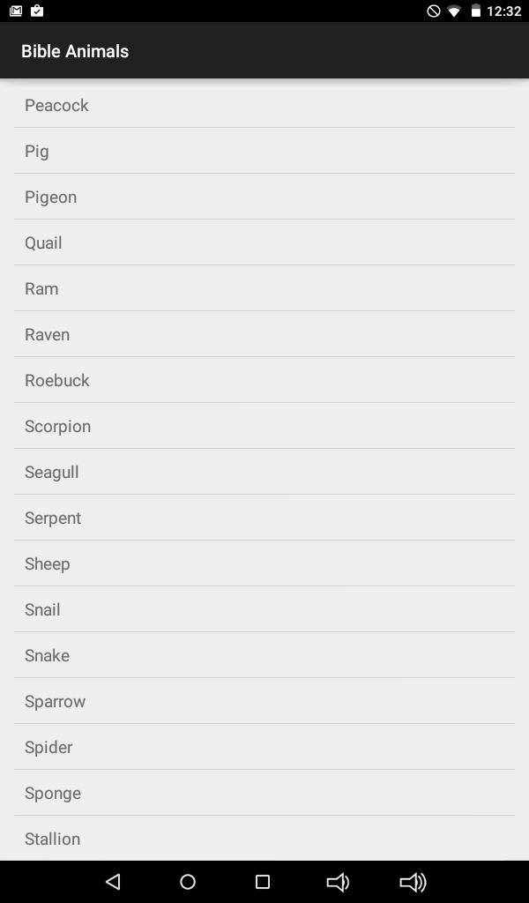

**No way to filter animals by book of the Bible**

Category: Lack of convenience

Severity Rating: 4/5 – This feature is not implemented, but it is something users want. Adding an option similar to categorizing by type of animal called categorizing by book of the Bible may help.



**Only one translation is used in the app**

Category: Lack of depth

Severity Rating: 3/5 – For more inquisitive users, this presents a problem as they may not be finding all the possible references for an animal.

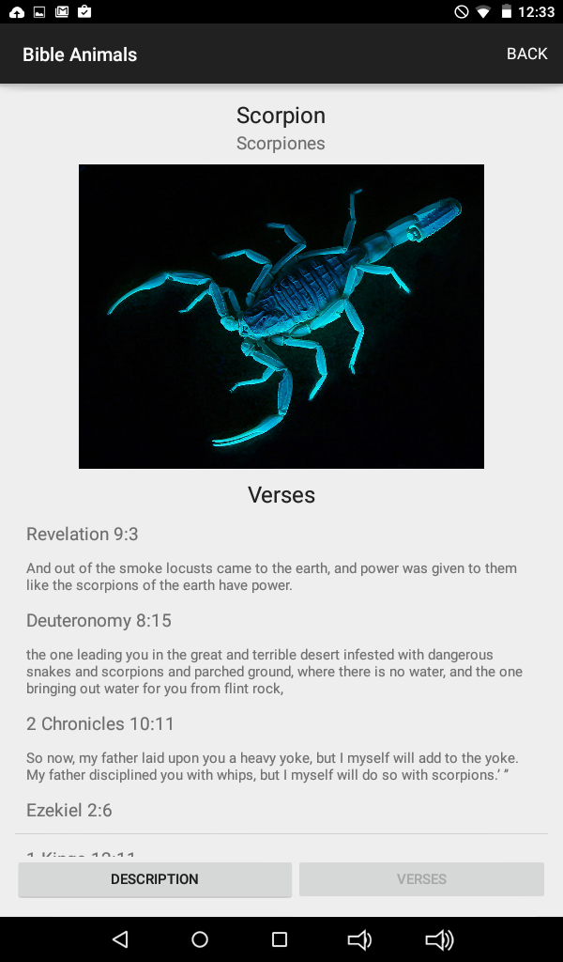

**Some of the animal’s descriptions are incomplete**

Category: Lack of depth

Severity Rating: 5/5 – Although not noticed by users, some of the animals are missing complete descriptions.

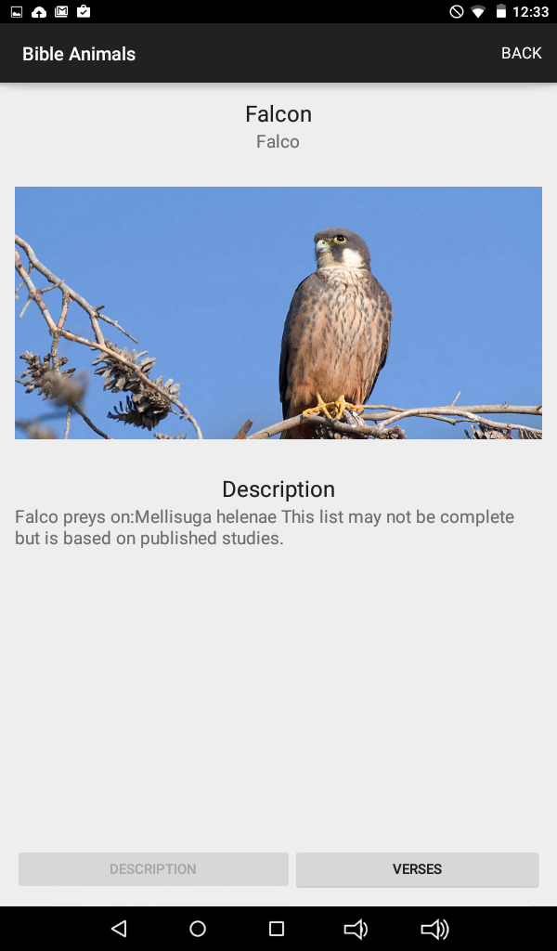

**The verses Animals appear in are in no apparent order**

Category: Lack of depth

Severity Rating: 3/5 – This is fairly annoying as the user cannot find a verse easily.

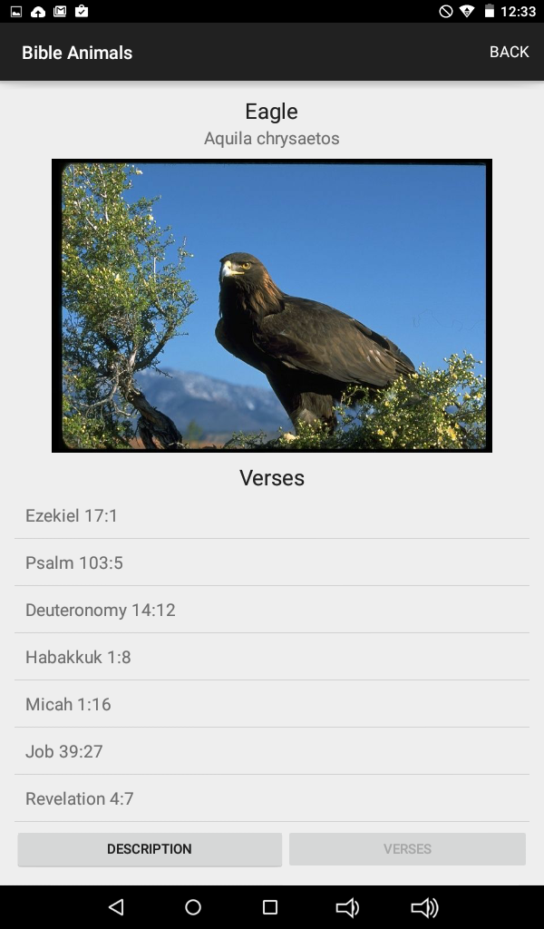

**No indication that users need to tap the verse text and go out of the app to view the chapter**

Category: Lack of indication

Severity Rating: 4/5 – This is something most users will want to do at some point or another, so making it intuitive is important.

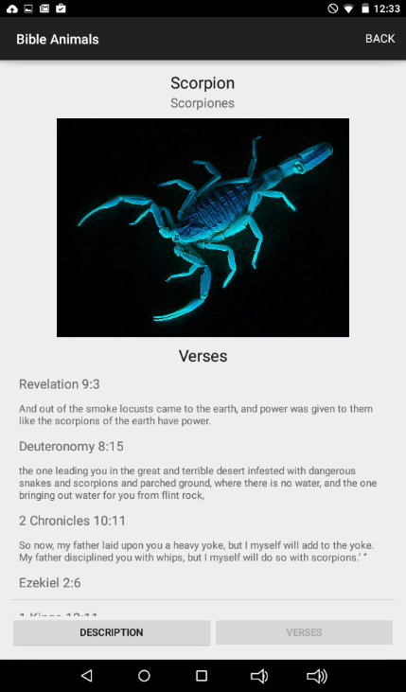

**No indication that users can tap a verse reference to view its text**

Category: Lack of indication

Severity Rating: 1/5 – Tapping the verse reference is rather intuitive but not obvious.

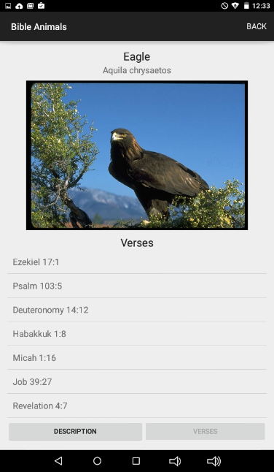

**Animals with names that have multiple meanings have incorrect verses**

Category: Lack of depth

Severity Rating: 3/5 – Animals like bear and fly list incorrect verses. This was also not noticed by users.

